Lab4 : Type Designer

Using Type Tree Maker

Objective

Equip you with the knowledge and understanding of WebSphere Transformation Extender Type Tree Maker and creation of a type tree using typetree maker.

By completing the exercises you will learn how to create a typetree using WebSphere Transformation Extender Type Tree Maker.

Type Tree Maker

The WebSphere Transformation Extender Type Tree Maker is a scripting tool that automates the capture of metadata from machine-processable sources to create graphical metadata in the form of type trees.

Environment

Windows OS, WTX8.4 TypeTree Maker.

List of components

- Employee.mts
- Employee.mtt.

Procedure

Step 1:

From the Windows Start menu, choose Programs > IBM Websphere Transformation Extender 8.4 > Design Studio > Type Tree Maker. click OK.

The Open dialog appears.



Step 2:

Select Employee.mts file from the directory C:\WTXTraining\WTX8.4\WTX_Lab3and Click Open.

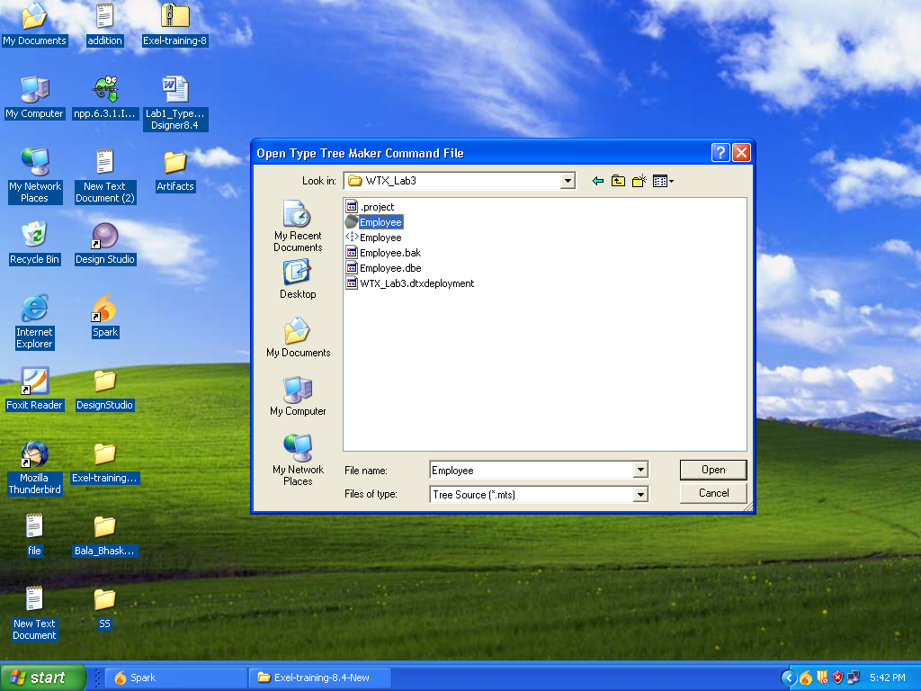

Step 3:

The type tree Employee.mtt file is generated with the message Command file completed successfully.

Click OK and Close

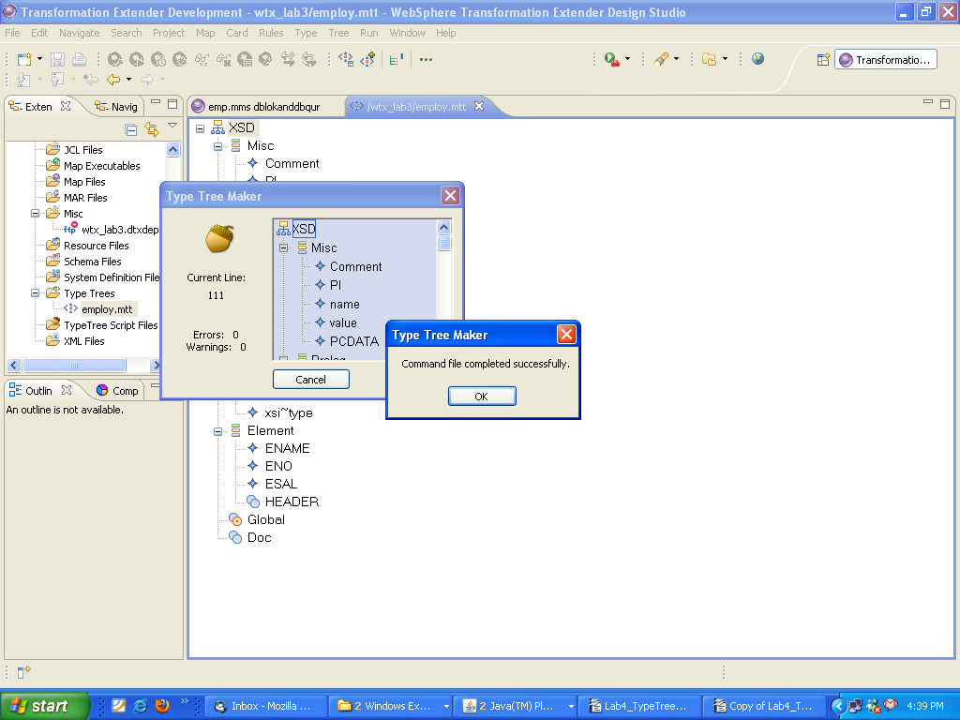

If we have any errors in the .mts file it will show the errors in a text file.

Step 4:

It will be saved in the folder C:\WTXTRAINING\WTX8.4\WTX_Lab3

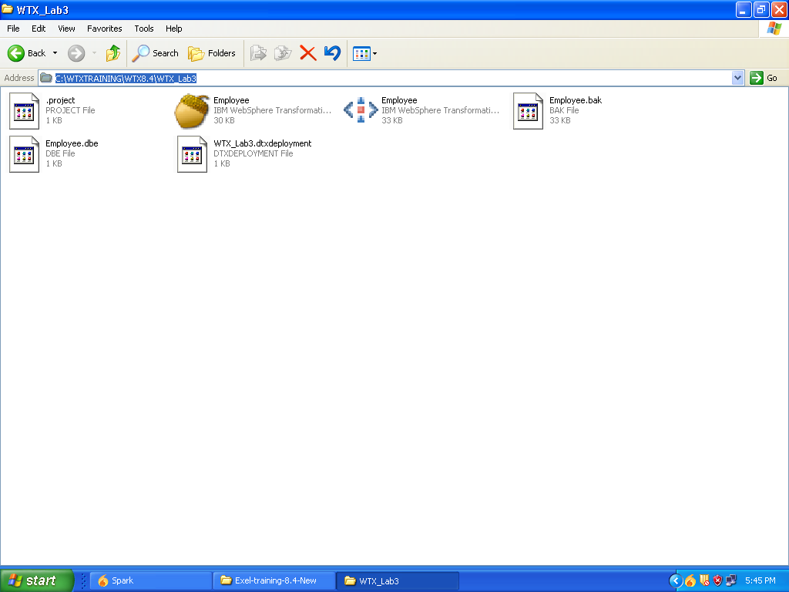

Step 5 :

The typetree will look like this

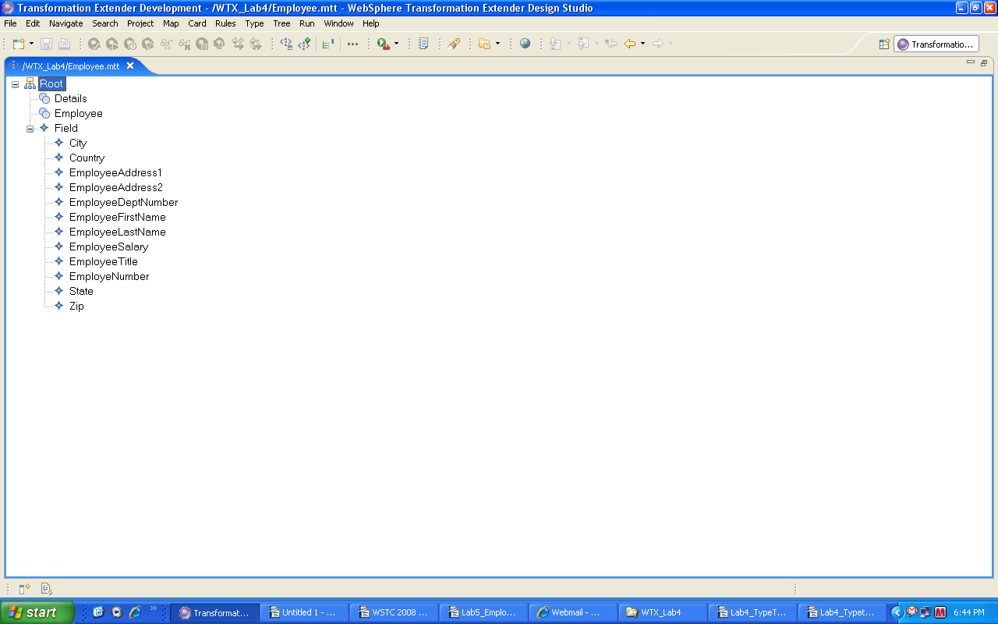

Limitations and Constraints:

1. When the Type Tree Maker finds a problem with a command, it creates either an error message or a warning message, depending on the severity of the problem. These error and warning messages that can be viewed from the Type Tree Maker window are also stored in the file ttmaker.log in your product installation directory. When the Type Tree Maker finishes running, view the errors and warnings in the ttmaker.log file.

2. The ttmaker.log file record contains the line number of the command that caused the error or warning message, followed by a message. An example of a warning message.

